Database development and evaluation

Part one-Retrieving Data from SQL

1. SELECT shopper_first_name, shopper_surname, shopper_email_address, FLOOR((JULIANDAY(DATETIME('now'))-JULIANDAY(date_of_birth))/365) AS 'Age', date_joined

FROM shoppers

ORDER BY shopper_first_name;

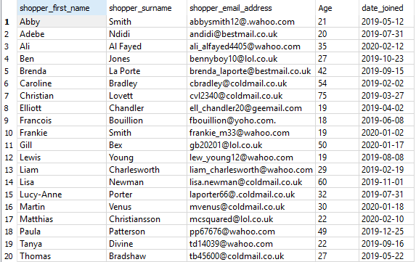

Part two

part three

Part four